|  |
| --- |
|  |
| 資策會101期 行動裝置程式開發作業 |
| 吳權峰 |

|  |
| --- |
| 2018/5/23 |

* 功能截圖及說明

1. APP進入主畫面

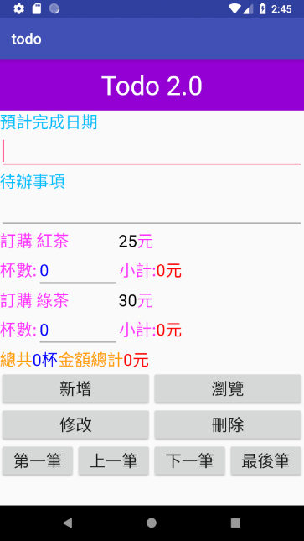 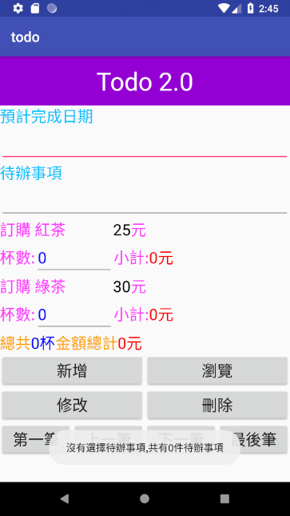

點擊標題顯示提示資訊

逐項瀏覽按鈕

1. 資料管理功能

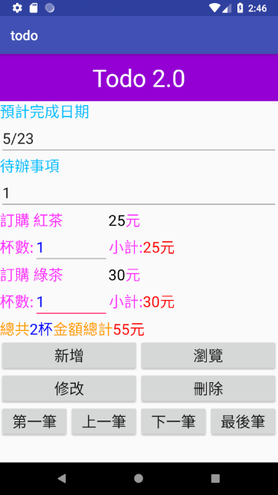 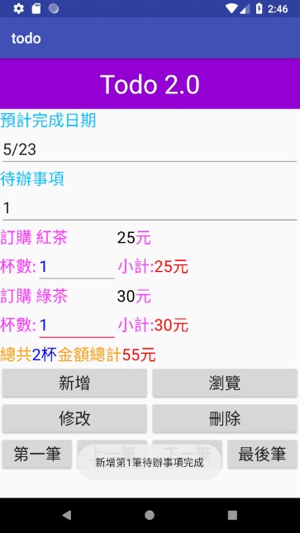

新增資料後提示資訊

變動杯數時自動計算

小計等數值

1. 瀏覽列表選取資訊細項

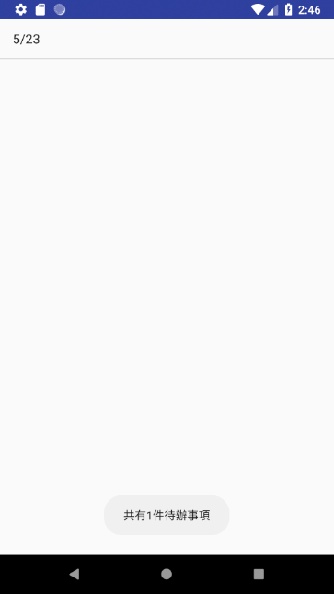 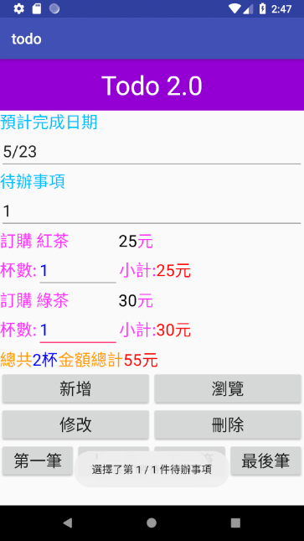

點選列表跳回主畫面顯示細項資料並顯示提示資訊

瀏覽功能跳至

所有待辦事項選單

並提示數量

1. 修改資料防止誤操作

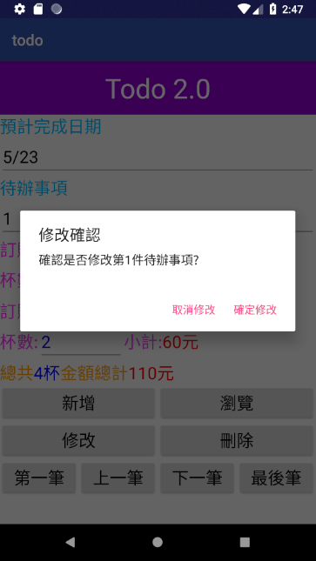 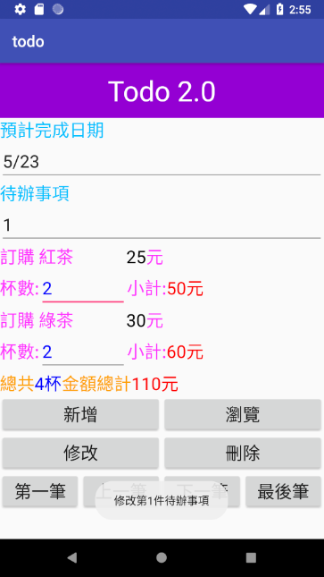

修改資料後提示資訊

修改資料前須先確認修改

1. 刪除資料防止誤操作

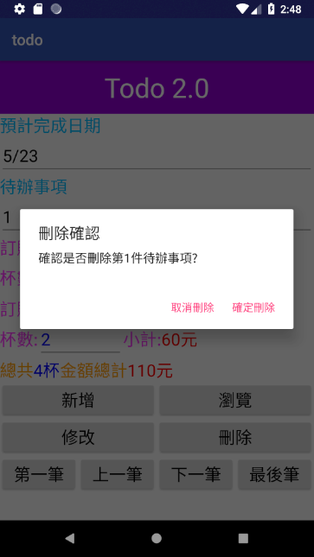 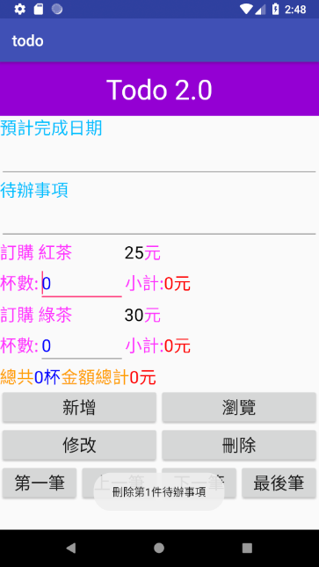

刪除資料後提示資訊

並且清空欄位

刪除資料前須先確認刪除

* 程式碼部分截圖

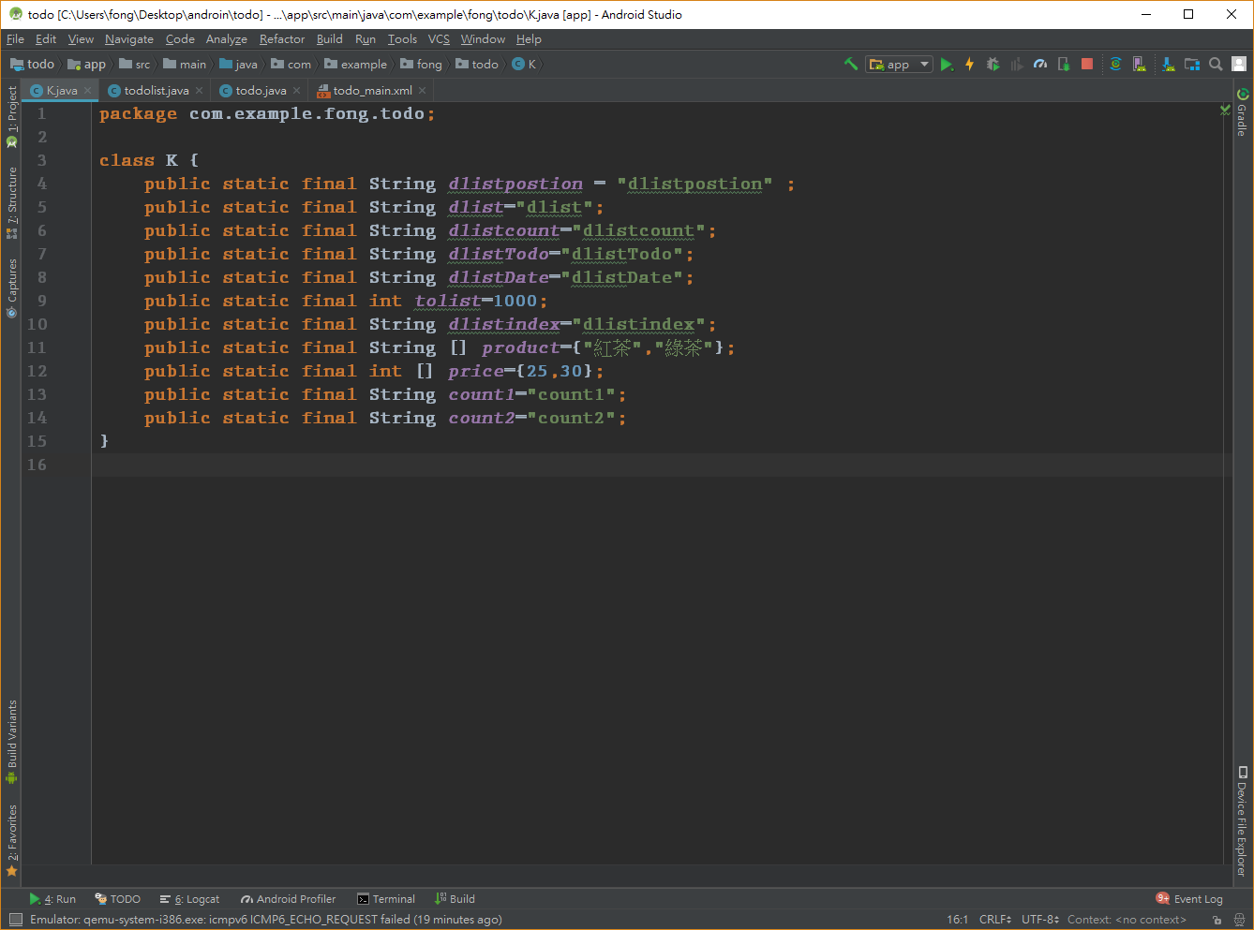

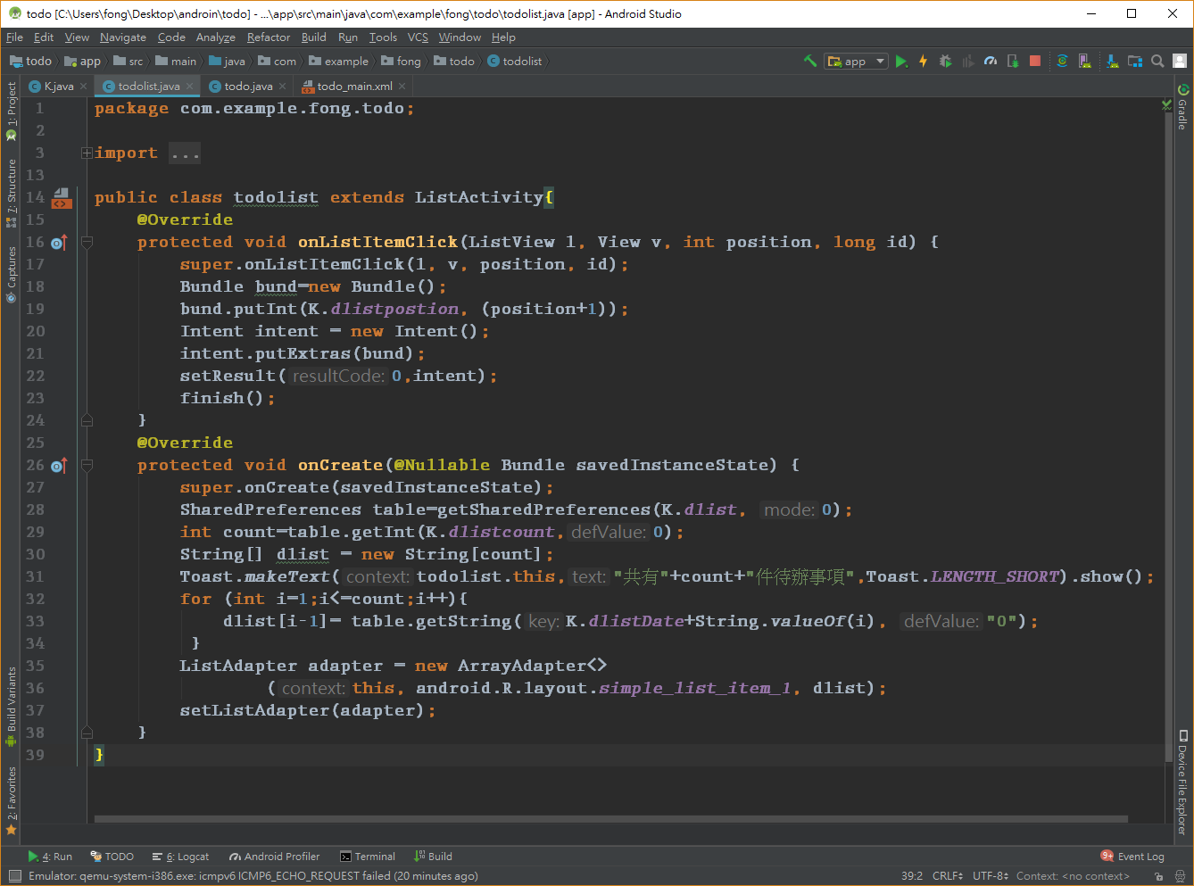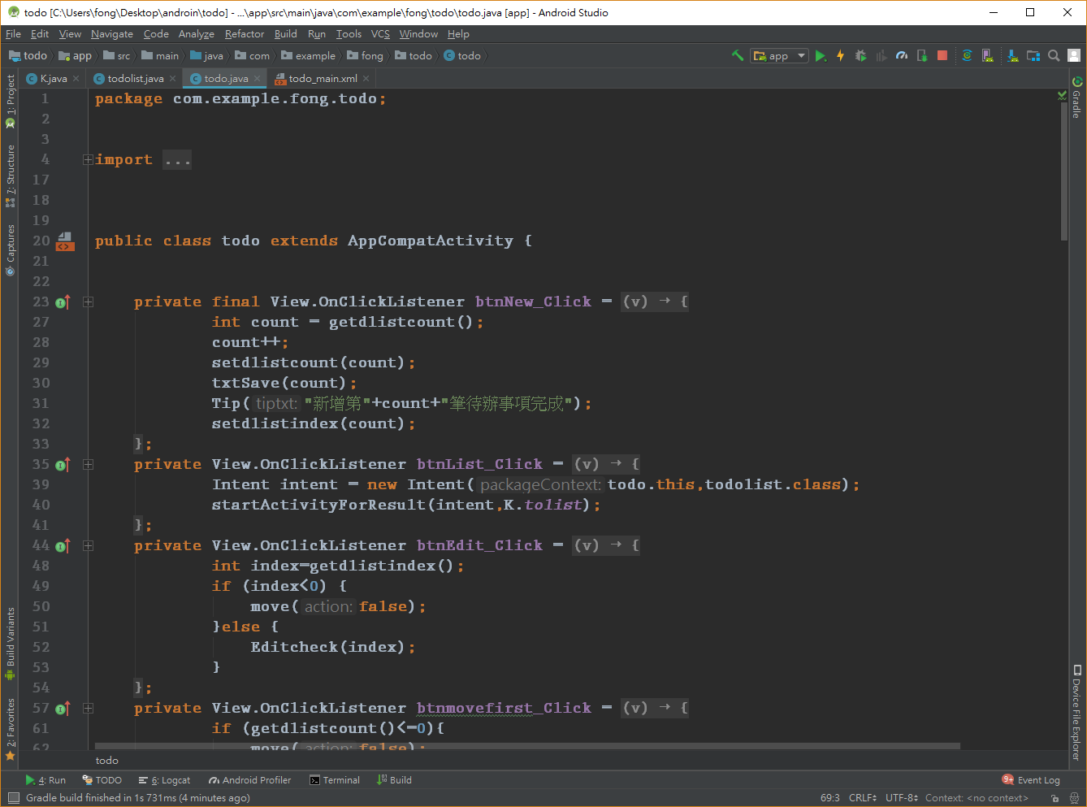

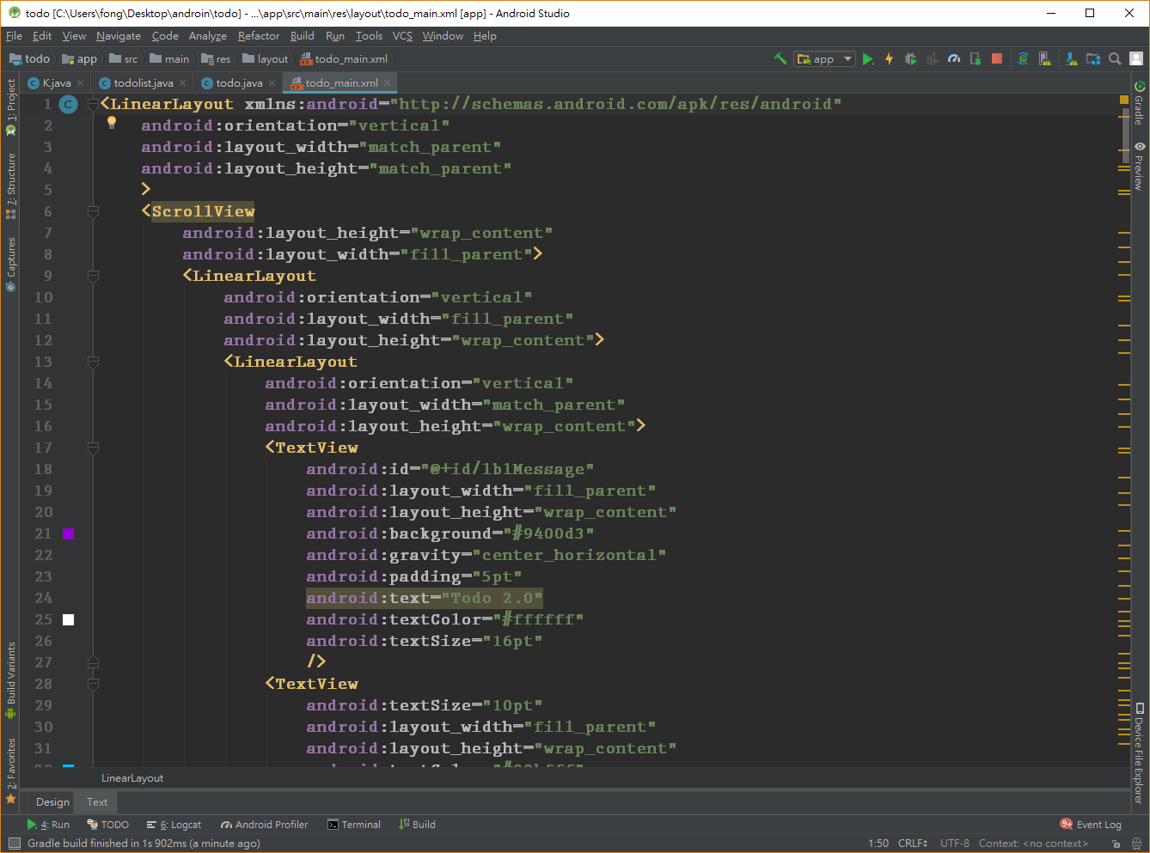

* 程式碼

1. K.java

package com.example.fong.todo;  
  
class K {  
 public static final String *dlistpostion* = "dlistpostion" ;  
 public static final String *dlist*="dlist";  
 public static final String *dlistcount*="dlistcount";  
 public static final String *dlistTodo*="dlistTodo";  
 public static final String *dlistDate*="dlistDate";  
 public static final int *tolist*=1000;  
 public static final String *dlistindex*="dlistindex";  
 public static final String [] *product*={"紅茶","綠茶"};  
 public static final int [] *price*={25,30};  
 public static final String *count1*="count1";  
 public static final String *count2*="count2";  
}

1. todolist.java

package com.example.fong.todo;  
  
import android.app.ListActivity;  
import android.content.Intent;  
import android.content.SharedPreferences;  
import android.os.Bundle;  
import android.support.annotation.Nullable;  
import android.view.View;  
import android.widget.ArrayAdapter;  
import android.widget.ListAdapter;  
import android.widget.ListView;  
import android.widget.Toast;  
  
public class todolist extends ListActivity{  
 @Override  
 protected void onListItemClick(ListView l, View v, int position, long id) {  
 super.onListItemClick(l, v, position, id);  
 Bundle bund=new Bundle();  
 bund.putInt(K.*dlistpostion*, (position+1));  
 Intent intent = new Intent();  
 intent.putExtras(bund);  
 setResult(0,intent);  
 finish();  
 }  
 @Override  
 protected void onCreate(@Nullable Bundle savedInstanceState) {  
 super.onCreate(savedInstanceState);  
 SharedPreferences table=getSharedPreferences(K.*dlist*, 0);  
 int count=table.getInt(K.*dlistcount*,0);  
 String[] dlist = new String[count];  
 Toast.*makeText*(todolist.this,"共有"+count+"件待辦事項",Toast.*LENGTH_SHORT*).show();  
 for (int i=1;i<=count;i++){  
 dlist[i-1]= table.getString(K.*dlistDate*+String.*valueOf*(i), "0");  
 }  
 ListAdapter adapter = new ArrayAdapter<>  
 (this, android.R.layout.*simple_list_item_1*, dlist);  
 setListAdapter(adapter);  
 }  
}

1. todolist.java

package com.example.fong.todo;  
  
  
import android.app.AlertDialog;  
import android.content.DialogInterface;  
import android.content.Intent;  
import android.content.SharedPreferences;  
import android.support.v7.app.AppCompatActivity;  
import android.os.Bundle;  
import android.text.Editable;  
import android.text.TextWatcher;  
import android.view.View;  
import android.widget.Button;  
import android.widget.EditText;  
import android.widget.TextView;  
import android.widget.Toast;  
  
  
  
public class todo extends AppCompatActivity {  
  
  
 private final View.OnClickListener btnNew_Click = new View.OnClickListener() {  
  
 @Override  
 public void onClick(View v) {  
 int count = getdlistcount();  
 count++;  
 setdlistcount(count);  
 txtSave(count);  
 Tip("新增第"+count+"筆待辦事項完成");  
 setdlistindex(count);  
 }  
 };  
 private View.OnClickListener btnList_Click = new View.OnClickListener(){  
  
 @Override  
 public void onClick(View v) {  
 Intent intent = new Intent(todo.this,todolist.class);  
 startActivityForResult(intent,K.*tolist*);  
 }  
  
 };  
 private View.OnClickListener btnEdit_Click = new View.OnClickListener(){  
  
 @Override  
 public void onClick(View v) {  
 int index=getdlistindex();  
 if (index<0) {  
 move(false);  
 }else {  
 Editcheck(index);  
 }  
 }  
  
 };  
 private View.OnClickListener btnmovefirst_Click = new View.OnClickListener(){  
  
 @Override  
 public void onClick(View v) {  
 if (getdlistcount()<=0){  
 move(false);  
 }else {  
 setdlistindex(1);  
 move(true);  
 }  
 }  
 };  
 private View.OnClickListener btnmoveback_Click = new View.OnClickListener(){  
  
 @Override  
 public void onClick(View v) {  
 if (getdlistcount()<=0){  
 move(false);  
 }else if ( getdlistindex()<=1) {  
 setdlistindex(1);  
 move(true);  
 }else {  
 setdlistindex(getdlistindex()-1);  
 move(true);  
 }  
 }  
  
 };  
 private View.OnClickListener btnmovenext_Click = new View.OnClickListener(){  
  
 @Override  
 public void onClick(View v) {  
 if (getdlistcount()<=0){  
 move(false);  
 }else if ((getdlistindex()==getdlistcount() || (getdlistindex()<=0))) {  
 setdlistindex(getdlistcount());  
 move(true);  
 }else {  
 setdlistindex(getdlistindex()+1);  
 move(true);  
 }  
 }  
  
 };  
 private View.OnClickListener btnmovelast_Click = new View.OnClickListener(){  
  
 @Override  
 public void onClick(View v) {  
 if (getdlistcount()<=0){  
 move(false);  
 }else if ( getdlistindex()==getdlistcount()) {  
 move(true);  
 }else {  
 setdlistindex(getdlistcount());  
 move(true);  
 }  
 }  
 };  
 private TextWatcher txtcount_addTextChangedListener;  
 {  
 txtcount_addTextChangedListener = new TextWatcher() {  
 @Override  
 public void beforeTextChanged(CharSequence s, int start, int count, int after) {  
  
 }  
  
 @Override  
 public void onTextChanged(CharSequence s, int start, int before, int count) {  
 int counmtsum=0;  
 int Sumtotal=0;  
 if (!txtcount1.getText().toString().matches("") ) {  
 int sum = Integer.*parseInt*(String.*valueOf*(txtcount1.getText()));  
 int price = Integer.*parseInt*(String.*valueOf*(txtprice1.getText()));  
 txtSubtotal1.setText(String.*valueOf*( sum * price));  
 counmtsum = counmtsum + sum;  
 Sumtotal = Sumtotal + sum * price;  
 }else{  
 txtcount1.setText("0");  
 }  
 if (!txtcount2.getText().toString().matches("") ) {  
 int sum = Integer.*parseInt*(String.*valueOf*(txtcount2.getText()));  
 int price = Integer.*parseInt*(String.*valueOf*(txtprice2.getText()));  
 txtSubtotal2.setText(String.*valueOf*( sum * price));  
 counmtsum = counmtsum + sum;  
 Sumtotal = Sumtotal + sum * price;  
 }else{  
 txtcount2.setText("0");  
 }  
 txtcounmtsum.setText(String.*valueOf*(counmtsum));  
 txtSumtotal.setText(String.*valueOf*(Sumtotal));  
 }  
  
 @Override  
 public void afterTextChanged(Editable s) {  
  
 }  
 };  
 }  
 private void Editcheck(final int index) {  
 new AlertDialog.Builder(this)  
 .setTitle("修改確認" )  
 .setMessage("確認是否修改第"+index+"件待辦事項?" )  
 .setPositiveButton("確定修改" , new DialogInterface.OnClickListener() {  
 public void onClick(DialogInterface dialog, int which) {  
 Tip("修改第" + index + "件待辦事項");  
 txtSave(index);  
 }  
 })  
 .setNegativeButton("取消修改" , new DialogInterface.OnClickListener() {  
 public void onClick(DialogInterface dialog, int which) {  
 Tip("取消修改第" + index + "件待辦事項");  
 txtLoad(index);  
 }  
 })  
 .show();  
 }  
 private final View.OnClickListener btnDel_Click = new View.OnClickListener() {  
  
 @Override  
 public void onClick(View v) {  
  
 int index = getdlistindex();  
 int count = getdlistcount();  
  
 if (index < 0) {  
 move(false);  
 } else {  
 Delcheck(index,count);  
 }  
 }  
  
 };  
  
 private void Delcheck(final int index, final int count) {  
 new AlertDialog.Builder(this)  
 .setTitle("刪除確認" )  
 .setMessage("確認是否刪除第"+index+"件待辦事項?" )  
 .setPositiveButton("確定刪除" , new DialogInterface.OnClickListener() {  
 public void onClick(DialogInterface dialog, int which) {  
 Tip("刪除第" + index + "件待辦事項");  
 Delrun(index,count);  
 }  
 })  
 .setNegativeButton("取消刪除" , new DialogInterface.OnClickListener() {  
 public void onClick(DialogInterface dialog, int which) {  
 Tip("取消刪除第" + index + "件待辦事項");  
 }  
 })  
 .show();  
 }  
  
 private void Delrun(int index, int count) {  
 for (;index<count;index++) {  
 setDate(index, getDate(index + 1));  
 setTodo(index, getTodo(index + 1));  
 }  
 txtnull();  
 setdlistcount(count-1);  
 setdlistindex(-1);  
 }  
 private View.OnClickListener lblMessage_Click = new View.OnClickListener(){  
  
 @Override  
 public void onClick(View v) {  
 int index=getdlistindex();  
 if (index<0) {  
 move(false);  
 }else {  
 move(true);  
 }  
 }  
 };  
 @Override  
 protected void onActivityResult(int requestCode, int resultCode, Intent data) {  
 super.onActivityResult(requestCode, resultCode, data);  
  
 if(data==null){  
 move(false);  
 setdlistindex(-1);  
 txtnull();  
 return;  
 }  
 if(data.getExtras()==null){  
 return;  
 }  
 if(requestCode==K.*tolist*){  
 int index=data.getExtras().getInt(K.*dlistpostion*);  
 setdlistindex(index);  
 move(true);  
 }  
 }  
 @Override  
 protected void onCreate(Bundle savedInstanceState) {  
 super.onCreate(savedInstanceState);  
 setContentView(R.layout.*todo_main*);  
 InitialComponent();  
 setdlistindex(-1);  
 Tip("點擊標題可重新讀入當前資訊");  
 txtproduct1.setText(K.*product*[0]);  
 txtproduct2.setText(K.*product*[1]);  
 txtprice1.setText(String.*valueOf*(K.*price*[0]));  
 txtprice2.setText(String.*valueOf*(K.*price*[1]));  
 txtcount1.setText("0");  
 txtcount2.setText("0");  
 }  
 private void move(boolean action) {  
 if (action){  
 Tip("選擇了第 " + getdlistindex() +" / "+getdlistcount()+ " 件待辦事項");  
 txtLoad(getdlistindex());  
 }else {  
 Tip("沒有選擇待辦事項,共有"+getdlistcount()+"件待辦事項");  
 }  
 }  
 private void txtLoad(int index) {  
 txtDate.setText(getDate(index));  
 txtTodo.setText(getTodo(index));  
 txtcount1.setText(String.*valueOf*(gettxtcount1(index)));  
 txtcount2.setText(String.*valueOf*(gettxtcount2(index)));  
 }  
 private void txtSave(int index) {  
 setTodo(index,txtTodo.getText().toString());  
 setDate(index,txtDate.getText().toString());  
 setcount1(index,Integer.*valueOf*(String.*valueOf*(txtcount1.getText())));  
 setcount2(index,Integer.*valueOf*(String.*valueOf*(txtcount2.getText())));  
 }  
 private void txtnull() {  
 txtDate.setText("");  
 txtTodo.setText("");  
 txtcount1.setText("0");  
 txtcount2.setText("0");  
 }  
 private void Tip(String tiptxt) {  
 Toast.*makeText*(todo.this,tiptxt,Toast.*LENGTH_SHORT*).show();  
 }  
 private void setDate(int index,String txt) {  
 SharedPreferences table = getSharedPreferences(K.*dlist*, 0);  
 table.edit().putString(K.*dlistDate* + String.*valueOf*(index),txt).apply();  
 }  
 private void setTodo(int index,String txt) {  
 SharedPreferences table = getSharedPreferences(K.*dlist*, 0);  
 table.edit().putString(K.*dlistTodo* + String.*valueOf*(index),txt).apply();  
 }  
 private void setdlistcount(int index) {  
 SharedPreferences table = getSharedPreferences(K.*dlist*, 0);  
 table.edit().putInt(K.*dlistcount*, index).apply();  
 }  
 public void setdlistindex(int index) {  
 SharedPreferences table = getSharedPreferences(K.*dlist*, 0);  
 table.edit().putInt(K.*dlistindex*, index).apply();  
 }  
 private void setcount1(int index, int count) {  
 SharedPreferences table = getSharedPreferences(K.*dlist*, 0);  
 table.edit().putInt(K.*count1*+ String.*valueOf*(index), count).apply();  
 }  
 private void setcount2(int index, int count) {  
 SharedPreferences table = getSharedPreferences(K.*dlist*, 0);  
 table.edit().putInt(K.*count2*+ String.*valueOf*(index), count).apply();  
 }  
 private int getdlistcount() {  
 SharedPreferences table = getSharedPreferences(K.*dlist*, 0);  
 return table.getInt(K.*dlistcount*,0);  
 }  
 private String getTodo(int index) {  
 SharedPreferences table=getSharedPreferences(K.*dlist*, 0);  
 return table.getString(K.*dlistTodo*+String.*valueOf*(index),"");  
 }  
 private String getDate(int index) {  
 SharedPreferences table=getSharedPreferences(K.*dlist*, 0);  
 return table.getString(K.*dlistDate*+String.*valueOf*(index),"");  
 }  
 private int getdlistindex() {  
 SharedPreferences table=getSharedPreferences(K.*dlist*, 0);  
 return table.getInt(K.*dlistindex*,-1);  
 }  
 private int gettxtcount1(int index) {  
 SharedPreferences table=getSharedPreferences(K.*dlist*, 0);  
 return table.getInt(K.*count1*+String.*valueOf*(index),0);  
 }  
 private int gettxtcount2(int index) {  
 SharedPreferences table=getSharedPreferences(K.*dlist*, 0);  
 return table.getInt(K.*count2*+String.*valueOf*(index),0);  
 }  
 private void InitialComponent() {  
 btnNew=findViewById(R.id.*btnNew*);  
 btnNew.setOnClickListener(btnNew_Click);  
 btnList=findViewById(R.id.*btnList*);  
 btnList.setOnClickListener(btnList_Click);  
 btnEdit=findViewById(R.id.*btnEdit*);  
 btnEdit.setOnClickListener(btnEdit_Click);  
 btnDel=findViewById(R.id.*btnDel*);  
 btnDel.setOnClickListener(btnDel_Click);  
 btnmovefirst=findViewById(R.id.*btnmovefirst*);  
 btnmovefirst.setOnClickListener(btnmovefirst_Click);  
 btnmoveback=findViewById(R.id.*btnmoveback*);  
 btnmoveback.setOnClickListener(btnmoveback_Click);  
 btnmovenext=findViewById(R.id.*btnmovenext*);  
 btnmovenext.setOnClickListener(btnmovenext_Click);  
 btnmovelast=findViewById(R.id.*btnmovelast*);  
 btnmovelast.setOnClickListener(btnmovelast_Click);  
 txtTodo=findViewById(R.id.*txtTodo*);  
 txtDate=findViewById(R.id.*txtDate*);  
 lblMessage=findViewById(R.id.*lblMessage*);  
 lblMessage.setOnClickListener(lblMessage_Click);//點擊標題可顯示資訊提示  
 txtproduct1=findViewById(R.id.*txtproduct1*);  
 txtprice1=findViewById(R.id.*txtprice1*);  
 txtcount1=findViewById(R.id.*txtcount1*);  
 txtcount1.addTextChangedListener(txtcount_addTextChangedListener);  
 txtSubtotal1=findViewById(R.id.*txtSubtotal1*);  
 txtproduct2=findViewById(R.id.*txtproduct2*);  
 txtprice2=findViewById(R.id.*txtprice2*);  
 txtcount2=findViewById(R.id.*txtcount2*);  
 txtcount2.addTextChangedListener(txtcount_addTextChangedListener);  
 txtSubtotal2=findViewById(R.id.*txtSubtotal2*);  
 txtcounmtsum=findViewById(R.id.*txtcounmtsum*);  
 txtSumtotal=findViewById(R.id.*txtSumtotal*);  
 }  
 Button btnNew ;  
 Button btnList;  
 Button btnEdit;  
 Button btnDel;  
 Button btnmovefirst;  
 Button btnmoveback;  
 Button btnmovenext;  
 Button btnmovelast;  
 EditText txtTodo;  
 EditText txtDate;  
 TextView lblMessage;  
 TextView txtproduct1;  
 TextView txtprice1;  
 EditText txtcount1;  
 TextView txtSubtotal1;  
 TextView txtproduct2;  
 TextView txtprice2;  
 EditText txtcount2;  
 TextView txtSubtotal2;  
 TextView txtcounmtsum;  
 TextView txtSumtotal;  
}

1. todo_main.xml

<LinearLayout xmlns:android="http://schemas.android.com/apk/res/android"  
 android:orientation="vertical"  
 android:layout_width="match_parent"  
 android:layout_height="match_parent"  
 >  
 <ScrollView  
 android:layout_height="wrap_content"  
 android:layout_width="fill_parent">  
 <LinearLayout  
 android:orientation="vertical"  
 android:layout_width="fill_parent"  
 android:layout_height="wrap_content">  
 <LinearLayout  
 android:orientation="vertical"  
 android:layout_width="match_parent"  
 android:layout_height="wrap_content">  
 <TextView  
 android:id="@+id/lblMessage"  
 android:layout_width="fill_parent"  
 android:layout_height="wrap_content"  
 android:background="#9400d3"  
 android:gravity="center_horizontal"  
 android:padding="5pt"  
 android:text="Todo 2.0"  
 android:textColor="#ffffff"  
 android:textSize="16pt"  
 />  
 <TextView  
 android:textSize="10pt"  
 android:layout_width="fill_parent"  
 android:layout_height="wrap_content"  
 android:textColor="#00bfff"  
 android:text="預計完成日期"  
 />  
 <EditText  
 android:id="@+id/txtDate"  
 android:textSize="10pt"  
 android:layout_width="fill_parent"  
 android:layout_height="wrap_content"  
 />  
 <TextView  
 android:textSize="10pt"  
 android:layout_width="fill_parent"  
 android:layout_height="wrap_content"  
 android:textColor="#00bfff"  
 android:text="待辦事項"  
 />  
 <EditText  
 android:id="@+id/txtTodo"  
 android:textSize="10pt"  
 android:layout_width="fill_parent"  
 android:layout_height="wrap_content"  
 />  
  
 </LinearLayout>  
 <LinearLayout  
 android:orientation="vertical"  
 android:layout_width="match_parent"  
 android:layout_height="wrap_content">  
 <LinearLayout  
 android:orientation="horizontal"  
 android:layout_width="wrap_content"  
 android:layout_height="wrap_content">  
 <TextView  
 android:textSize="10pt"  
 android:layout_width="fill_parent"  
 android:layout_height="wrap_content"  
 android:textColor="#ff33ff"  
 android:text="訂購 "  
 />  
 <TextView  
 android:id="@+id/txtproduct1"  
 android:textSize="10pt"  
 android:layout_width="50pt"  
 android:layout_height="wrap_content"  
 android:textColor="#ff33ff"  
 android:text="品項1"  
 />  
 <TextView  
 android:id="@+id/txtprice1"  
 android:textSize="10pt"  
 android:layout_width="fill_parent"  
 android:layout_height="wrap_content"  
 android:textColor="#000000"  
 android:text="單價1"  
 />  
 <TextView  
 android:textSize="10pt"  
 android:layout_width="fill_parent"  
 android:layout_height="wrap_content"  
 android:textColor="#ff33ff"  
 android:text="元"  
 />  
 </LinearLayout>  
 <LinearLayout  
 android:orientation="horizontal"  
 android:layout_width="match_parent"  
 android:layout_height="wrap_content">  
 <TextView  
 android:textSize="10pt"  
 android:layout_width="wrap_content"  
 android:layout_height="wrap_content"  
 android:textColor="#ff33ff"  
 android:text="杯數:"  
 />  
 <EditText  
 android:id="@+id/txtcount1"  
 android:textSize="10pt"  
 android:layout_width="50pt"  
 android:layout_height="wrap_content"  
 android:inputType="number"  
 android:ems="3"  
 android:textColor="#0000ff"  
 />  
 <TextView  
 android:textSize="10pt"  
 android:layout_width="wrap_content"  
 android:layout_height="wrap_content"  
 android:textColor="#ff33ff"  
 android:text="小計:"  
 />  
 <TextView  
 android:id="@+id/txtSubtotal1"  
 android:textSize="10pt"  
 android:layout_width="wrap_content"  
 android:layout_height="wrap_content"  
 android:textColor="#FF0000"  
 android:text="0"  
 />  
 <TextView  
 android:textSize="10pt"  
 android:layout_width="fill_parent"  
 android:layout_height="wrap_content"  
 android:textColor="#FF0000"  
 android:text="元"  
 />  
 </LinearLayout>  
 </LinearLayout>  
 <LinearLayout  
 android:orientation="vertical"  
 android:layout_width="match_parent"  
 android:layout_height="wrap_content">  
 <LinearLayout  
 android:orientation="horizontal"  
 android:layout_width="wrap_content"  
 android:layout_height="wrap_content">  
 <TextView  
 android:textSize="10pt"  
 android:layout_width="fill_parent"  
 android:layout_height="wrap_content"  
 android:textColor="#ff33ff"  
 android:text="訂購 "  
 />  
 <TextView  
 android:id="@+id/txtproduct2"  
 android:textSize="10pt"  
 android:layout_width="50pt"  
 android:layout_height="wrap_content"  
 android:textColor="#ff33ff"  
 android:text="品項2"  
 />  
 <TextView  
 android:id="@+id/txtprice2"  
 android:textSize="10pt"  
 android:layout_width="fill_parent"  
 android:layout_height="wrap_content"  
 android:textColor="#000000"  
 android:text="單價2"  
 />  
 <TextView  
 android:textSize="10pt"  
 android:layout_width="fill_parent"  
 android:layout_height="wrap_content"  
 android:textColor="#ff33ff"  
 android:text="元"  
 />  
 </LinearLayout>  
 <LinearLayout  
 android:orientation="horizontal"  
 android:layout_width="match_parent"  
 android:layout_height="wrap_content">  
 <TextView  
 android:textSize="10pt"  
 android:layout_width="wrap_content"  
 android:layout_height="wrap_content"  
 android:textColor="#ff33ff"  
 android:text="杯數:"  
 />  
 <EditText  
 android:id="@+id/txtcount2"  
 android:textSize="10pt"  
 android:layout_width="50pt"  
 android:layout_height="wrap_content"  
 android:inputType="number"  
 android:ems="3"  
 android:textColor="#0000ff"  
 />  
 <TextView  
 android:textSize="10pt"  
 android:layout_width="wrap_content"  
 android:layout_height="wrap_content"  
 android:textColor="#ff33ff"  
 android:text="小計:"  
 />  
 <TextView  
 android:id="@+id/txtSubtotal2"  
 android:textSize="10pt"  
 android:layout_width="wrap_content"  
 android:layout_height="wrap_content"  
 android:textColor="#FF0000"  
 android:text="0"  
 />  
 <TextView  
 android:textSize="10pt"  
 android:layout_width="fill_parent"  
 android:layout_height="wrap_content"  
 android:textColor="#FF0000"  
 android:text="元"  
 />  
 </LinearLayout>  
  
 </LinearLayout>  
 <LinearLayout  
 android:orientation="horizontal"  
 android:layout_width="match_parent"  
 android:layout_height="match_parent">  
 <TextView  
 android:textSize="10pt"  
 android:layout_width="wrap_content"  
 android:layout_height="wrap_content"  
 android:textColor="#ff9d00"  
 android:text="總共"  
 />  
 <TextView  
 android:id="@+id/txtcounmtsum"  
 android:textSize="10pt"  
 android:layout_width="wrap_content"  
 android:layout_height="wrap_content"  
 android:textColor="#0000ff"  
 android:text="0"  
 />  
 <TextView  
 android:textSize="10pt"  
 android:layout_width="wrap_content"  
 android:layout_height="wrap_content"  
 android:textColor="#0000ff"  
 android:text="杯"  
 />  
 <TextView  
 android:textSize="10pt"  
 android:layout_width="wrap_content"  
 android:layout_height="wrap_content"  
 android:textColor="#ff9d00"  
 android:text="金額總計"  
 />  
 <TextView  
 android:id="@+id/txtSumtotal"  
 android:textSize="10pt"  
 android:layout_width="wrap_content"  
 android:layout_height="wrap_content"  
 android:textColor="#FF0000"  
 android:text="0"  
 />  
 <TextView  
 android:textSize="10pt"  
 android:layout_width="fill_parent"  
 android:layout_height="wrap_content"  
 android:textColor="#FF0000"  
 android:text="元"  
 />  
 </LinearLayout>  
 <LinearLayout  
 android:layout_width="match_parent"  
 android:layout_height="wrap_content"  
 android:orientation="horizontal">  
 <Button  
 android:id="@+id/btnNew"  
 android:layout_width="fill_parent"  
 android:layout_height="wrap_content"  
 android:layout_weight="1"  
 android:text="新增"  
 android:textSize="10pt"  
 />  
 <Button  
 android:id="@+id/btnList"  
 android:layout_width="fill_parent"  
 android:layout_height="wrap_content"  
 android:layout_weight="1"  
 android:text="瀏覽"  
 android:textSize="10pt"  
 />  
 </LinearLayout>  
  
 <LinearLayout  
 android:layout_width="match_parent"  
 android:layout_height="wrap_content"  
 android:orientation="horizontal">  
  
 <Button  
 android:id="@+id/btnEdit"  
 android:layout_width="fill_parent"  
 android:layout_height="wrap_content"  
 android:layout_weight="1"  
 android:text="修改"  
 android:textSize="10pt" />  
  
 <Button  
 android:id="@+id/btnDel"  
 android:layout_width="fill_parent"  
 android:layout_height="wrap_content"  
 android:layout_weight="1"  
 android:text="刪除"  
 android:textSize="10pt" />  
 </LinearLayout>  
 <LinearLayout  
 android:layout_width="match_parent"  
 android:layout_height="wrap_content"  
 android:orientation="horizontal">  
 <Button  
 android:id="@+id/btnmovefirst"  
 android:layout_width="fill_parent"  
 android:layout_height="wrap_content"  
 android:layout_weight="1"  
 android:text="第一筆"  
 android:textSize="10pt"  
 />  
 <Button  
 android:id="@+id/btnmoveback"  
 android:layout_width="fill_parent"  
 android:layout_height="wrap_content"  
 android:layout_weight="1"  
 android:text="上一筆"  
 android:textSize="10pt"  
 />  
 <Button  
 android:id="@+id/btnmovenext"  
 android:layout_width="fill_parent"  
 android:layout_height="wrap_content"  
 android:layout_weight="1"  
 android:text="下一筆"  
 android:textSize="10pt"  
 />  
 <Button  
 android:id="@+id/btnmovelast"  
 android:layout_width="fill_parent"  
 android:layout_height="wrap_content"  
 android:layout_weight="1"  
 android:text="最後筆"  
 android:textSize="10pt"  
 />  
 </LinearLayout>  
 </LinearLayout>  
 </ScrollView>  
</LinearLayout>